**Josephine Ann Wolfe-Fischer Family**

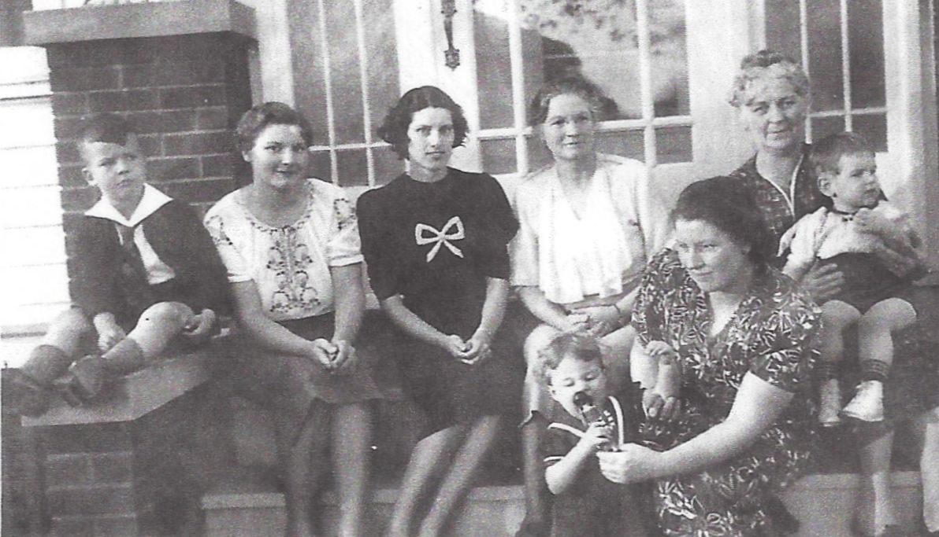

**Ronald L. List, Josephine A. Wolfe, Cecile Worthen, Josephine S. Worthen Wolfe,**

**Anna Worthen holding David W. List, and Dorothy E. Wolfe List with daughter,**

**Dorothy Joanne List – about 1939**

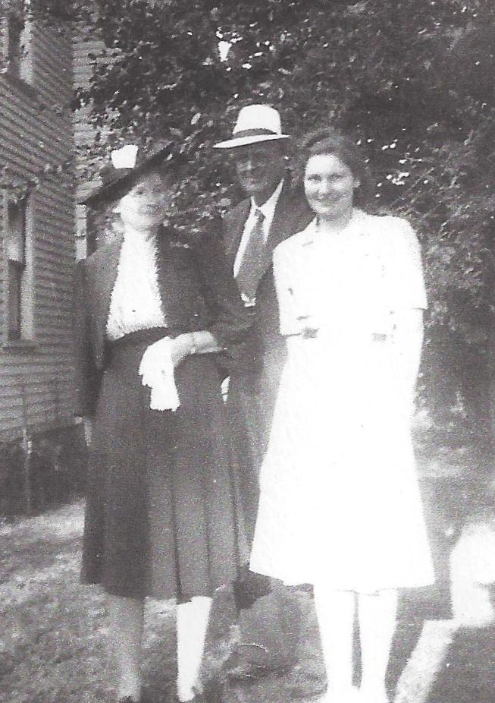

**Josephine S. Worthen and Earl Russell Wolfe,**

**and daughter, Josephine Ann Wolfe - 17 August 1941**